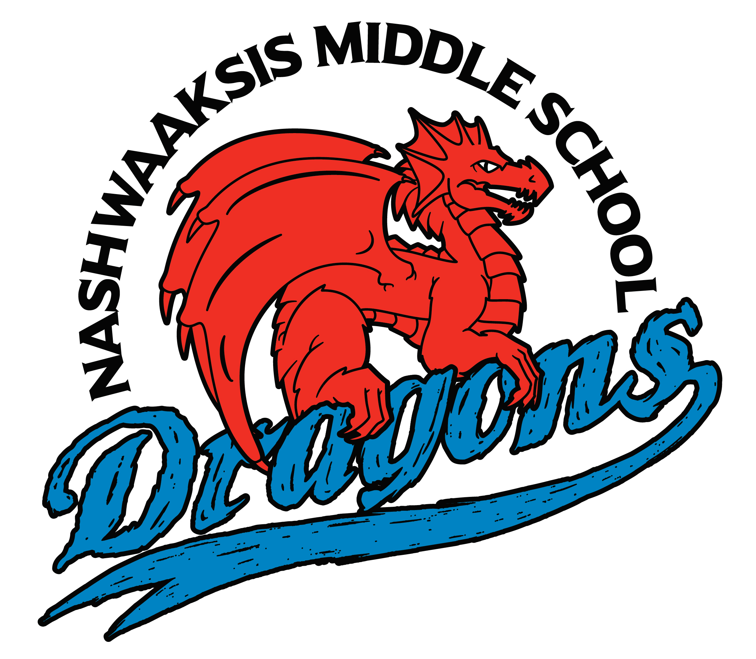

# Nashwaaksis Middle School

324 Fulton Avenue, Fredericton, NB E3A 5J4

Phone: (506) 453-5436 FAX: (506) 444-4129

**Grade 7 & 8 School Supply List**

**2024 – 2025**

NMS Student fee this year is **$45/student** this is to cover the costs of many school supplies, locks, physical education equipment and school activities. Payment is preferred via cashless schools but can also by paid by cash or cheque made payable to Nashwaaksis Middle School.

Students will also need to bring the following items:

* Book bag
* Water bottle
* Headphones (3.5mm aux corded/ NO apple, wireless or Bluetooth products as they will not work)
* 2 – 3 Large Binders
* Loose leaf (800 pages)
* Pencil case with the following items: pencils, pens, eraser, highlighter and calculator
* Box of pencils (24)
* Pencil Crayons
* Markers
* Lunch bag
* Kleenex (2 boxes)

**Physical Education**: A change of clothing is required:

Indoor **Non-Marking** Sneakers, shorts/gym pants, T-shirt, Unscented Deodorant (due to allergies in the school)

**More supplies may be asked for throught the year if needed

*For any lost locks there will be a $5 fee to receive a new one.